Shabbos Stories for
Parshas pinchas 5782
Volume 13A, Issue 48 – 24 Tammuz 5782/July 23, 2022
Printed L’illuy nishmas Nechama bas R’ Noach, a”h

For a free subscription, please forward your request to keren18@juno.com
Past stories can be found on the website ShabbosStories.com

Getting the Brisker Rav
Out of the Tax Office

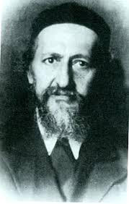

The Brisker Rav was extremely careful never to accept gifts of any kind, even under the most difficult of circumstances. When he first arrived in Eretz Yisroel in 1941, he was detained in the passport control office.
The group of people awaiting the great Rebbe was told that the Rabbi did not have the money with which to pay the tax, and it was forbidden to allow entry to anyone who had not paid.
One of the leaders offered to pay the tax for the Brisker Rav, but he staunchly refused, and said, “Never in my life have I taken money from anyone.”
After much deliberation, an old resident of Brisk had an idea. He entered the office and approached the Brisker Rav and said, “The members of the Brisker Community who have come to Eretz Yisroel want the Rav to continue serving as our Rav.
“We will pay the Rav a salary just as we did in Brisk. Therefore, I want to either give, or lend, the Rav the money to pay the tax, which will then be deducted from his salary.”
The Brisker Rav considered for a minute and then said, “That is an offer that I can accept,” and he agreed to accept the money to pay his tax!
Reprinted from the Parshs Chukas 5782 email of Rabbi Yehuda Winzzelberg’s Torah U’Tefilah
Story #1282
On the Way Down the Masada Snake Path
From the Desk of Yerachmiel Tilles
By Eliezer Shore

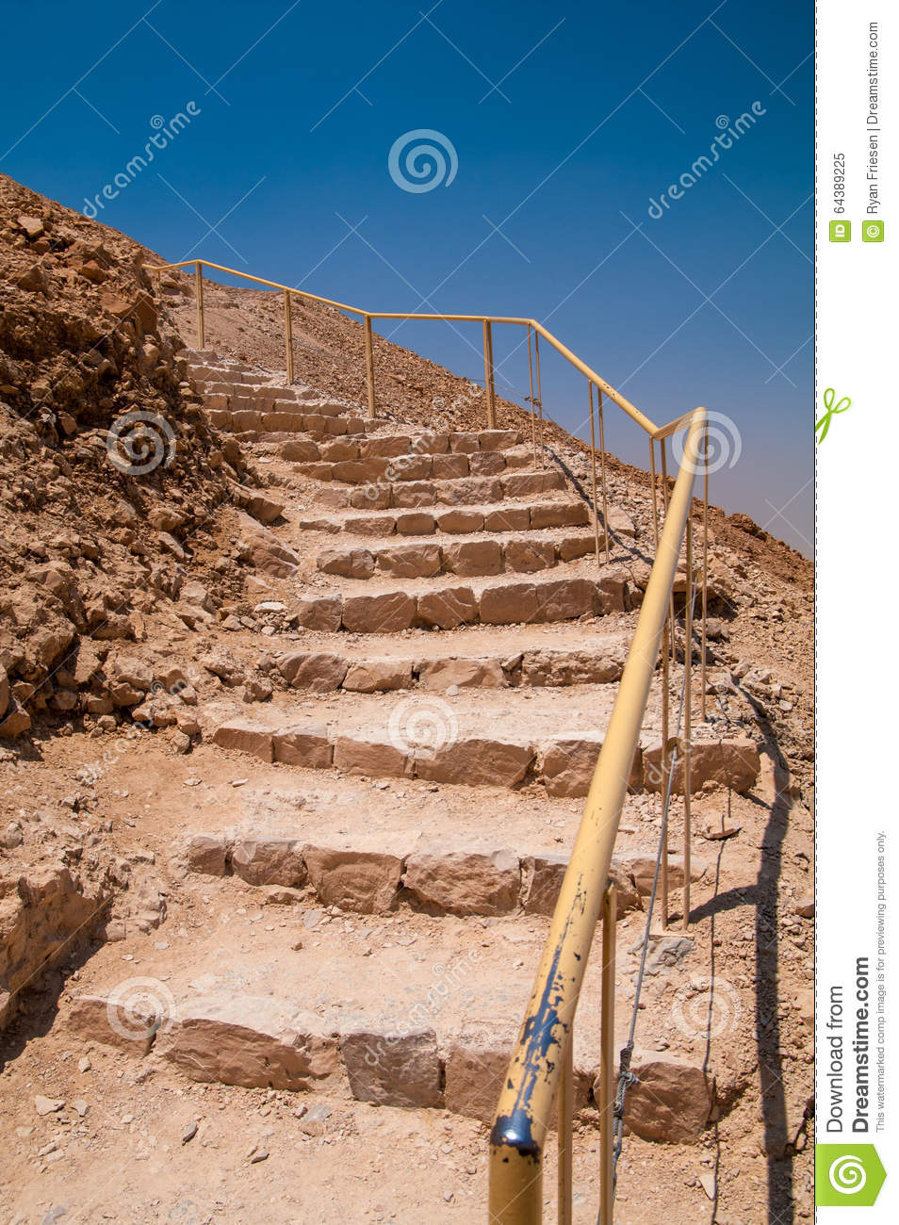

I stopped and shook the pebbles out of my shoe for the third time. This was a big mistake, I thought. How could we be so stupid?
I glanced up at the trail behind us. Sitting atop the mountain was the Masada fortress, all pale and austere in the noonday sun. The light blinded my eyes, and I had to look away.
I turned to face our destination the visitor’s center at the bottom of the mountain, where we had parked our car. How much longer! We were all so hot and thirsty; how were we ever going to make it?
What had started out as an exciting Chol HaMoed adventure was quickly becoming a life-threatening situation. We had awoken early that day one of the intermediate days of Sukkot and had driven down toward the Dead Sea. There was me, my husband, our four kids ages four to nine and my brother-in-law. Our plan was to take the cable car to the top of Masada, and then walk back down the mountain along the steep and windy trail known as the Snake Path. We had heard that it was a hard path, but doable.

A Little Past Mid-Day, We
Headed Down the Trail
The ride up the mountain was an adventure in itself, with my kids screaming, every time the cable car shook or swayed in the breeze. We spent a couple of hours walking around the fortress, touring the museum, and marveling at the magnificent view of the Judean Desert. A little past mid-day, we headed down the trail, snacks and water bottles in hand.
But we had sorely miscalculated. The day was much hotter than we expected, even for mid-autumn it must have been 90 degrees. Parts of the trail were extremely steep and hard to navigate, and we had to support our children from falling. The baby carriage, carrying our four-year-old, was especially difficult to navigate down the rocky steps and slope. It was a four-mile walk, which the average hiker could do in about forty-five minutes. We had been at it for almost an hour and were still far from the bottom.
Worse of all, our snacks and water ran out almost immediately. We were all suffering from the heat. My kids were starting to cry, and I was seriously concerned that they would suffer from dehydration.
My husband and I looked at each other in consternation. Let’s just keep going. There was nothing much else to say. I felt that my knees would give out at any moment. I said a silent prayer for help.

What Was He Doing There?
For a reason that I don’t remember, I broke away from the group, and walked up ahead. I was thus quite surprised to come across a man sitting alone on a stone bench, out in the open sun. What was he doing there? Going up? Going down?
He was a heavy-set man, in his mid-forties, with a swarthy face and dark hair. He needed a shave. He wore a khaki vest, like a security guard, and I noticed a gun in a holster on his belt. There was a black knapsack on the ground beside him. Oddest of all he was jabbing a scissor in his ear!
He spoke up when he saw me. Hey, could you please come and help me?
I froze. I didn’t need this. We just wanted to get to the bottom. I looked around to see if there was any way to circumvent him, but the path was narrow and delineated. I remembered hearing about a 20-year-old college student who had recently fallen to her death, after straying from the marked path.
I have something in my ear, and I need help getting it out the man said, in a beseeching tone. That explained his use of the scissors.
I approached him in trepidation. I bent over and looked in his ear. A small stick seemed to be lodged deep inside.
I was scratching my ear, when the stick broke and left the end inside, he explained.

A Combination of Sympathy
And Mild Repulsion
I nodded in sympathy, mildly repulsed.
Let me try those scissors, I said.
I tried pinching the end of the stick with them but couldn’t get hold of it. By now, my family had caught up and were all standing around, watching.
I put my fingers in his ear and tried pinching the stick with my nails, but it was too deep inside. The man smelled of sweat. His hair was greasy and damp, and his clothing needed a wash. Disgusting.
My husband came over to help me. He took hold of the man’s earlobe and pulled it down and away, while I extended both pinky fingers and tried to grab the stick with my nails.
Finally, I got a hold of the end and started pulling it out. I hope he doesn’t explode I thought humorously to myself.
It was a thin bamboo stick, like a kebab skewer. I pulled a little more, and a little more, and a little more it was four inches long! I thought of Mary Poppins pulling a hat rack out of her carpet bag. How did he get this in his ear? Was he trying to scratch his brain? I dropped it to the ground in disgust.

My Whole Family Cheered and Applauded
The man let out a huge sigh, as though I had saved his life “Oh, my G-d“ and my whole family cheered and applauded. I think I was the only one who realized how bizarre the situation truly was. (Secretly, I was also proud of myself. Both my husband and his brother are doctors, and it was nice to show off my own healing skills, as well.)
The man picked up his knapsack and reached inside. I became tense again. “What’s he up to now?” I thought.
With a flourish, he pulled out a large plastic bottle full of ice water right in the middle of the Snake Path, in 95-degree heat!
“Thanks so much for helping me,” he said. “Would you guys like a drink?”
We all melted at the sight. “Oh yes! Thank you!” we cried in unison. We passed the bottle back and forth, drinking until we were revived and ready to continue. I felt like I had passed a test I had helped him, and he had saved us.
We thanked each other again and wished each other a happy holiday. Then my family turned to continue down the mountain. The strange man remained sitting on the bench, as though he had no place better to go.

Took a Final Look – He Vanished Like a Mirage
I had not walked five feet, when I turned around to have a final look in his direction. But he was gone. Vanished like a mirage. The bench was empty, the trail was empty, and as far as I could see, the entire side of the mountain was empty. I couldn’t discern a single place where he might have hidden. He simply disappeared into thin air.
He wasn’t a person, I announced to my family. He was an angel! We all stared in amazement.
About forty minutes later, we were back in our car, air conditioner blasting, music blaring, heading back to Jerusalem. That was about fifteen years ago. But even today, I think about our trip to the desert fortress, and the impression the whole trip made on me. It always makes me think of another Fortress, to whom I still raise my eyes: “I will say to Hashem, ˜You are my refuge and my fortress, my G-D, in whom I trust” (Psalms 91:2).

* * *
Source : Rabbi Dr. Eliezer Shore currently lives in Jerusalem, where he is a published writer and author, storyteller, and Torah teacher. The above story, which he was told by Rachel Berger, appears in his newest book, Meeting Elijah, available from Amazon . To receive more of his stories through email, please go to: Elijah stories.subscribemenow.com.
Connection: Just like in the Weekly Reading of Chukat (this past week in Israel; this week outside of Israel) The people did not have any water. (Num. 20:2)

Reprinted from the Parshat Chukat 5782 email of KabbalahOnline.org, a project of Ascent of Safed.

The Yid Who Gave the Revolutionary a Talis

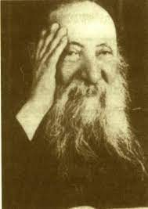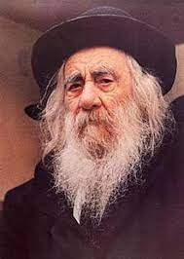
Rabbi Yaakov Galinksy, Rav Chaim Ozer Grodzensky and the Steipler Gaon

Rav Yaakov Galinsky demonstrates with a story how powerful an act of Chesed can really be, and how one has no idea how far one small act of Chesed can go.
During the time of the Russian Revolution, Czar Nicholas was the most hated man in Russia, and a group of revolutionaries decided to overthrow him. The leader of this group quickly became the most wanted man in Russia, and a manhunt was quickly organized to apprehend this criminal.
One day, some soldiers spotted him riding on a horse, and they chased him into a small town. He quickly jumped off his horse and ran into the first house he could find. A Yid answered the door but refused to hide the fugitive, because he was afraid both of them would get caught.
The man quickly ran to the next house, and another Yid answered the door. He begged the Yid to let him in and hide him. He promised him that if he would, although he didn’t yet know how, that someday he would repay him.
The Yid stepped aside, and helped him hide. He told the fugitive to change his clothing, and then he handed him a Tallis. He showed him how to put it on, and he taught him how to make the motions of someone who is Davening. When the Czar’s army came knocking on the doors, they eventually came to this Yid’s house, and when they entered, the Yid said, “We are just a couple of Jews praying.”
They saw the man wrapped in a Tallis, and thought nothing of it, so they left. The fugitive thanked the Yid and reiterated his promise to help him one day. Years later, the revolutionaries were able to overthrow the Czar, and this fugitive became a man of great power.
One day this Yid received an invitation to the capital. When he arrived, he was greeted by this man that he had saved. The fugitive asked, “Do you recognize me?” He told the Yid who he was and he gave him great wealth, and access to him for anything that he may need.
Years later, in 1921, eighteen Yeshivah Bochrim from the Novardok Yeshivah tried to cross the border illegally. They were caught and faced a severe prison term. Someone on their behalf went to Rav Chaim Ozer Grodzensky for help. Rav Chaim told them this story and advised them to go to this Yid and ask for his help.
The Yid went straight to the Capital, and asked his friend the President to intervene, and the Bochrim were saved. One of these Bochrim was Rav Yaakov Yisroel Kanievsky, the Steipler Gaon!

Reprinted from the Parshs Chukas 5782 email of Rabbi Yehuda Winzzelberg’s Torah U’Tefilah

Who Are You to Criticize?
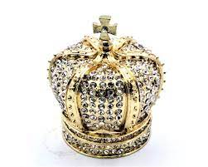

It is related that the tzadik, Rav Nochum of Horodna zt”l, disagreed with the ways of the Baal Shem Tov zy”a. However, when he once happened to hear people in his vicinity speaking negatively about the Besh”t, he became very upset and rebuked them.
He told them the following moshol: There once were two ministers who loved the king. They both wanted to do something to bring joy to the king and decided to make him a beautiful and glorious new crown. They hired famous craftsmen and spent a fortune to have the crown created.
However, when the crown was almost finished, the two ministers got into a heated argument about where to affix one particularly beautiful and valuable stone. One minister said the stone should be on one side of the crown, while the other said it should be on the other side.
Obviously, they both had the same intention. They both wanted the stone to be in the best place, where it could add glory and beauty to the crown. They both intended to honor the king as much as they could.
A simple villager overheard the argument and approached the men. He examined the crown and gave them his opinion by telling them which minister he thought was right.
Both of them yelled at him, “You fool! Why are you sticking your head into matters that are beyond your ability to understand!? We both understand the value of the crown and we both recognize the greatness of the king. We just disagree about where to put this stone. But who are you to speak at all about something you can’t understand?”
Rav Nochum ended his story and told the people, “The machlokes between me and the Besh”t is a machlokes l’shem shomayim. We disagree about what is the best way to honor Hashem. Disagreements like this have occurred before – between Shaul and Dovid, between Hillel and Shammai, and others. But why would you stick your heads into matters that you have no understand of?”

Reprinted from the Parshat Korach 5782 email of The Way of Emunah.

The Rosh Hayeshiva’s Unexpected “Blessing”

Horav Yechiel Tzuker, Shlita, relates a story that took place in the winter of 2016. Horav Avraham Altman, Shlita (Rosh Yeshivas Ateres Tzvi), and his son, Horav Eliyahu Meir, take an annual trip to Argentina on behalf of their yeshivah. They spend a few weeks meeting members of the community, speaking in the various shuls and raising badlyneeded funds for the yeshivah.
It was Shabbos morning after Musaf, and Rav Altman had delivered a powerful speech that shook up the congregation. Everyone was impressed and complimented him. As he was leaving, he was approached by a middle-aged Jew who said that he, together with his partner, owned a large factory which produced trousers.
He offered to invite the Rav and his distinguished son to visit the factory. He would make it worth their while. They visited the next day and, as the owner had promised, he gave them a cheque that made the trip worth their while.
Suddenly, in the midst of the conversation, the man broke down in bitter weeping. He explained that he had a partner who was dealing with a female client. One thing had led to another, and the relationship between him and the client had breached the parameters of pure business, and a not-so-platonic relationship ensued. He was now bent on marrying her. She was a gentile, and he was now prepared to turn his back on Yahadus, on the religion for which his ancestors had died.

Asks to Go Out to Lunch Before His Flight Back to the Holy Land
The man continued to weep. Rav Altman asked to meet the partner. The man was a bit nervous to meet a Rosh Yeshivah from Eretz Yisrael, but his partner came out and graciously received the Rosh Yeshivah. Rav Altman said, “Your partner gave me a generous check from the business. I would like to thank you since it is a joint account. Perhaps we could all go out to lunch tomorrow before we fly back to the Holy Land.”
The partners agreed to meet at a restaurant for lunch. During lunch, Rav Altman interrupted the conversation twice to express his fascination with the partner. He said he did not know why, but something about his visage had impressed him. Clearly, receiving such compliments made the partner feel very good. It was not every day that he was complimented so much.
“Tell me, are you married?” the Rosh Yeshivah asked.
“No, not yet,” was his response.
“I give you a blessing that this year should be the year that you find your bashert, Heavenly-designated spouse. Indeed, I will attend the wedding and dance with you!”

Unaware of What the Rav Knew
The partner was clueless that Rav Altman was aware that he was about to marry out of the faith. “What will I do?” he mused to himself. “The Rosh Yeshivah will dance with me in a church and the priest will be ‘mesader kiddushin,’ perform the service?”
A few months passed, and the religious partner received a call from his partner. He was weeping bitterly, “I cannot go through with it! How can I, a distinguished Jew with whom the Rosh Yeshivah from Eretz Yisrael is fascinated, marry a gentile? I am breaking the engagement!”
A few months passed, and he was engaged again – only this time to a frum, observant girl.

A Reason to Smile
By Rabbi Nachman Seltzer

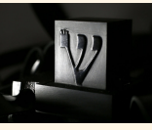

Shlomo Reichenberg lived through the Holocaust, suffering like so many members of Klal Yisrael. At one point, he was sent to a relatively small concentration camp with a population of some three thousand inmates. There he tried to stay under the radar as best he could.
One day, as he was walking outside his barracks, he was suddenly set upon by a Jew he didn’t know — a man he had never spoken to, a total stranger to him. Inexplicably, and without warning, this stranger began punching and beating him, to the point where he literally caused him to bleed!
Shlomo couldn’t understand why he was being attacked. “What are you doing?!” The man continued hitting him with his fists. “Stop hitting me!” he cried. But the Jew carried on, beating Shlomo with all his might.
It took a while, but the beating finally came to an end. Blood was flowing from his wounds, and he was in agony. “Why did you hit me?” he demanded. “I don’t even know you!”
“That doesn’t matter,” the other replied.
“It does matter! I don’t understand. Why did you lift up your fists and hit me?” “You will now come with me to Barrack 10,” the stranger said. “There we will learn the truth about you and why I just beat you up.”
It was obvious that he wasn’t being given a choice. Shlomo Reichenberg followed his attacker to Barrack 10, wondering what lay in store for him. It didn’t take Shlomo long to understand why they were going to Barrack 10. One of the prisoners housed there was the Jew who served as the unofficial arbitrator of all disagreements, arguments, and fights within the camp.

Being Led to Be Judged
Shlomo’s attacker was leading him to this man, to be judged — for what, he still did not know. They were allowed into the barrack and brought before the judge. “What is the nature of your disagreement?” he asked them.
Shlomo spoke first. “I was walking outside my barrack this morning,” he began, “when this man” — he pointed at his attacker — “began beating me up for no reason. He punched me and slapped me and made me bleed… and I don’t even know why! I have never seen him before and have certainly never exchanged two words with him. Yet he decided to attack me unprovoked and for no obvious reason!”
The judge turned to the attacker. “What do you have to say for yourself?”
“I had a very good reason for hitting this man,” the attacker said.
“Yes?”
“I saw him smiling to himself as he stood outside his barracks. Not once, but twice.”
“So what if he was smiling?” the judge asked. “Why is that a reason to attack him?”

Starving People Do Not Smile
“Let’s analyze the situation,” the man said. “Everyone in the camp is slowly starving to death. The Nazis barely give us enough food to keep body and soul together. Now, you and I both know that people who are starving do not smile. And yet, I saw this man smiling — as I said, not once, but twice. Let’s take a minute to understand what that means. “If he is smiling, then it stands to reason he isn’t starving, because starving people do not smile.
Yet how is it possible that he isn’t starving when every single inmate is suffering from not having enough to eat? The answer is simple. The reason he isn’t starving is because he is working with the Nazis, who are giving him extra rations as a reward for his collaboration.
“I am sure you will agree that a Nazi collaborator deserves to be beaten even worse than the beating I gave this man! That is why I attacked him.”
The judge turned back to Shlomo and said, “He makes a strong argument, or at least raises a solid question. How do you respond?”
Shlomo looked at the judge and at his attacker and made the decision to tell them the secret that lay behind his smile. “You have just accused me of being a Nazi collaborator,” he told the attacker. “You made the erroneous calculation that, seeing me smile, I must be working with the enemy since only then would I have enough food.
“What if you were wrong? What if a person can, in fact, smile for reasons that have nothing to do with having enough food? I will explain what I am talking about. “A few months ago, I and a few of my friends were somehow able to get hold of a pair of tefillin. I cannot go into the details of how we managed to do this, but since that great day, I have been able to don a pair of tefillin every morning.

The Merit of Being Able to Wear Tefillin
‘When you saw me smile, I was thinking about the fact that I have had the merit to wear tefillin even here, in this terrible place, and how my connection with the Ribbono Shel Olam is still intact, even here, in this form of Gehinnom.
“That is why I smiled, not once, but twice. It had nothing to do with food, and everything to do with the satisfaction I receive from my ongoing connection with Hashem. I am so lucky. I have a pair of tefillin to put on every morning. As a Jewish man who has been granted such incredible good fortune, how can I not smile?”
Needless to say, the judge ruled in favor of Reb Shlomo Reichenberg.

Reprinted from the Parshas Chukas 5782 edition of At the ArtScroll Shabbos Table, excerpted from the book “Zera Shimshon – Eishes Chayil” by Rabbi Nachman Selter.

The Gold Disc Segulah

In Czarist Russia, a man had to visit the capital city but was afraid. The rampant anti-Semitism was even harsher in large cities and he feared for his life. Though he would wear a hat and would not appear overtly Jewish, he feared that he would be beaten or worse.
He went to his Rebbe, and asked for protection.
"Hashem is with His children at all times, you need not be afraid," said the Rabbi.
"But, Rebbe," pleaded the man, "I need extra protection, you must help me."
The sage said nothing but rose and went into his private study, returning with a small velvet pouch. From it, he pulled a small, burnished gold disc, which looked like a small shield.
"Carry this with you, and remember that Hashem is your protector."
The man was overjoyed and carefully put the pouch into his pocket. His trip to the capital was not only safe, but the extra confidence he had made it more successful than he had imagined.
Upon his return, he thanked the Rebbe for the shield. "This worked so well," said the traveler, "where did you acquire it?"
"It was Hashem who protected you, my child," said the Rebbe. "As for this," he said, reattaching the disc to the front of his pocket watch, "I bought it from Mendel the watchmaker."

Reprinted from the Parshas Chukas 5782 email of Jonathon Gewirtz’s Midgal Ohr.

In His Hands

There is a story in Living Emunah 3 about a businessman on a flight, seated next to an unaccompanied little girl. After the plane took off, she took out her crayons and coloring book and happily kept herself occupied.
About an hour into the flight, the aircraft suddenly experienced extreme turbulence. The pilot’s voice came over the PA system, asking everyone to fasten their seatbelts and remain calm as they encountered rough weather. The plane made drastic dips and turns and shook for the next half hour.
People were crying and praying; the businessman was sweating and holding on to his seat as tightly as he could. Meanwhile, the little girl, about eight years old, sat quietly. Her crayons and coloring book were put away neatly in the seat pocket in front of her, and her hands rested folded in her lap. She was the picture of calm.
When the turbulence ended and the plane finally began its descent to land, the man asked the little girl, “How did you manage to remain calm the entire flight, especially since you are here all alone?” She looked at the man and said, “My father is flying the plane. He is the best pilot, and he’s taking me home.”
The little girl felt secure because she was in her father’s hands. When a Jew knows he’s in Hashem’s hands, he has peace of mind. Look up towards the Heavens like B’nei Yisrael were told to. Remember that we depend on Hashem, and He will always care for us, whether it’s health, financial success, a shidduch, or anything else!

May we realize how important it is to follow and trust Hashem, even for a mitzvah that we may not understand. May we always know, like with the rock and the mann, that Hashem is the source of our sustenance. May we continually pray to Him to give everyone in the community happiness, health, and success!! Amen!

Reprinted from the Parshat Chukat 5782 email of Jack E. Rahmey as based on the Torah teachings of Rabbi Amram Sananes.

Enjoy Your Shabbat
By Rabbi Paysach J. Krohn

It was Friday, January 21, 2018 and the weather was as stormy as could be in Ramat HaSharon, a coastal town near Tel Aviv. As the clock ticked and there remained just hours until Shabbos, dozens of men, women and children circulated around the Yohananoff supermarket located at Haroshet St 18.
But then, suddenly, what any supermarket manager never wishes to happen, in fact did. Thunder and lightning pierced the skies, and the lights went out. Customers stood still, wondering if this was just a temporary issue that would be resolved quickly or last some time.
Knowing that this could happen, the supermarket was equipped with generators, which kicked in, and did their job of ensuring that no food would spoil. But what the generators did not turn back on were the electronic cash registers.
Tzvi Abraham, manager of Yohananoff supermarket, had one of two ideas. He could either ask everyone to wait until the electricity would turn back on, and everyone could then pay at the cash registers. Alternatively, he could send everyone out and ask them to shop someplace else.
But it was getting late and Shabbos was just a few hours away. After consulting with his boss, Tzvi Abraham had a brilliant idea. Without any loudspeaker, he began announcing aloud, “I just spoke to my boss. It is now late Friday afternoon, and everyone should take their food home. Just write down what you took and go home, and you can return on Sunday and pay for what you took. Enjoy your Shabbat! We do not know when the electricity will turn back on and we don’t know if you will be able to make it to other stores, given the weather. Just take your food and go home and enjoy Shabbat.”
Nobody could believe it, though everyone began writing down what they had in their carts, with some people leaving their name and number near the cash registers. Tzvi Abraham insisted that everyone follow this protocol and not feel bad taking food now and only returning later to pay their dues.

That Sunday, 70% of the people returned to pay what they had taken, and by the following Friday, 100% had returned to pay.
Care, concern and connection. That’s what it’s all about.

Reprinted from the Parashat Chukat 5782 email of Rabbi David Bibi’s Shabbat Shalom from Cyberspace.

Ledger of the Society for Feeding the Hungry (Jerusalem, circa 1890)

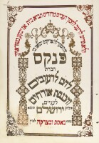

This ledger was offered unsuccessfully in the 2015 Sotheby’s Judaica Auction in New York City.

